
SRM Institute of Science and Technology
SET B

College of Engineering and Technology
School of Computing
DEPARTMENT OF COMPUTING TECHNOLOGIES
SRM Nagar, Kattankulathur – 603203, Chengalpattu District, Tamilnadu
Academic Year: 2022-2023 (Even)
Test: CLAT-2 Date: 05/04/2023
Course Code & Title: 18CSE360T-Information Storage and Management Duration: 12.30 to 2.15 PM
Year & Sem: III/ V Max. Marks: 50

Course Articulation Matrix:
Sl.No | Course Outcomes | PO1 | PO2 | PO3 | PO4 | PO5 | PO6 | PO7 | PO8 | PO9 | P10 | P11 | P12
1 | CO1 | M |  | - | - | - | - | - | - | - | L | - | - M
2 | CO2 | M | M | M | M | - | - | - | - | - | M | - | - H
3 | CO3 | M | M | M | M | - | - | - | - | - | L | - | - H
4 | CO4 | M | M | L | L | - | - | - | - | - | M | - | - H
5 | CO5 | L | M |  | - | - | - | - | - | - | M | - | - H
6 | CO6 | M |  | - | - | - | - | - | - | - | L | - | - H

Part - A
( 15 x1 = 15 Marks)
Instructions: Answer all
Q. No | Question | Marks | BL | CO | PO | PI Code
1 | Fibre channel Arbitrated Loop occurs when we use  - Hubs B)Switches  C) Routers D)Directors | 1 | 1 | 2 | 1 | 1.3.1
2 | Which of the following is used for shorter distance data transmission?  A) Single Mode Fiber  B) Multi Mode Fiber  C) Lucent Connector  D) Standard Connector | 1 | 1 | 2 | 1 | 1.3.1
3 | Flow control in FC technology is implemented by maintaining the maximum number of frames in a link by  A) Buffer B) Buffer to Buffer credit  C) End to End credit D) Receive Ready | 1 | 2 | 2 | 3 | 3.1.1
4 | Object based storage device supports web service access via  A)REST B)CAS  C)NFS D)CIFS | 1 | 1 | 2 | 1 | 1.3.1
5 | A repository at a remote site where data can be periodically copied so that there is always a copy at another site is  A)Hot site B)Cold site  C)Data center D)Data vault | 1 | 2 | 2 | 1 | 1.3.1
6 | An identifier used to uniquely identify the iSCSI initiators and targets within an iSCSI network is  A)WWN B)WWPN  C)iSCSI name D)WPN | 1 | 2 | 2 | 1 | 1.3.1
7 | NAS performance is not affected by  A)More number of hops  B)low latency  C)Over utilized routers  D)over utilized switches | 1 | 2 | 2 | 1 | 1.3.1
8 | Time required to repair a failed component is  A)MTBF B)MTTR  C)MTBR D)MTTF | 1 | 2 | 3 | 1 | 1.3.1
9 | The recovery time objective is  - Amount of downtime the business can endure  - Amount of data loss a business can endure  - Amount of time to which data must be recovered  - Amount of time needed to restart a business | 1 | 2 | 3 | 1 | 1.3.1
10 | Which backup method copies the data that has changed since the last full or incremental backup?  A)Full backup  B) Incremental backup  C) Cumulative backup  D)periodical backup | 1 | 2 | 3 | 3 | 3.1.1
11 | Backup server not  A)initiates scheduled backup process  B)sends data to backup device  C)updates the backup catalog  D)retrieves backup-related information | 1 | 1 | 3 | 1 | 1.3.1
12 | LAN performance is not degraded in  - direct-attached backup,  - LAN-based backup,  - SAN-based backup  - Mixed backup | 1 | 2 | 3 | 1 | 1.3.1
13 | In which of the following backup data is sent directly from the NAS head to the backup device, whereas metadata is sent to the backup server?  A)Server-less backup  B)Sever based backup  C)NDMP based backup  D) direct NAS backup | 1 | 2 | 3 | 1 | 1.3.1
14 | Which expression represents availability of a system in terms of MTBF and MTTR?  A) MTTR/(MTBF*MTTR)  B)MTBF/(MTBF*MTTR)  C)MTTR/(MTBF+MTTR)  D)MTBF/(MTTR+MTBF) | 1 | 2 | 3 | 1 | 1.3.1
15 | In traditional backup approach  - Offloads the backup processing from the hypervisor  - Creates a copy of the guest OS  - Backup agent on the VM backs up the VM data  - Enables quick restoration of a VM | 1 | 2 | 3 | 1 | 1.3.1
Part – B
( 5 x 5 = 25 Marks)
Instructions: Answer all
16 | With a suitable diagram compare implementations of iSCSI topologies with and without using FC components. | 5 | 3 | 2 | 3 | 3.1.1
17 | Discuss the architecture of an ideal storage solution that supports object based storage and access. | 5 | 4 | 2 | 3 | 3.1.1
18 | Specify the role and function of various nodes of backup architecture. | 5 | 3 | 3 | 3 | 3.1.1
19 | Research and prepare a presentation to demonstrate a business continuity life cycle plan. | 5 | 3 | 3 | 3 | 3.1.1
20 | A company is considering implementing storage. They do not have a current storage infrastructure to use, but they have a network that gives them good performance. Discuss whether native or bridged iSCSI should be used and explain your recommendation. | 5 | 3 | 3 | 3 | 3.1.1
Part – C
( 1 x 10= 10 Marks)
Instructions: Answer all
26 | Discuss the way how the NAS implementation provides the capability to scale up their resources based on data growth and rise in performance requirements. | 10 | 3 | 2 | 3 | 3.1.1
(OR)
27 | - A system has three components and requires all three to be operational during 8 a.m. to 5 p.m. business hours, Monday through Friday. Failure of component 2 occurs as follows:  Monday = 8 a.m. to 11 a.m.  Tuesday = No failure  Wednesday = 4 p.m. to 7 p.m.  Thursday = 5 p.m. to 8 p.m.  Friday = 1 p.m. to 2 p.m.  Calculate the availability of component 2.  - There are limited backup devices in a file sharing NAS environment. Suggest a suitable backup implementation that will minimize the network traffic, avoid any congestion, and at the same time not impact the production operations. Justify your answer. | 10 | 3 | 3 | 3 | 3.1.1

Course Outcome (CO) and Bloom’s level (BL) Coverage in Questions 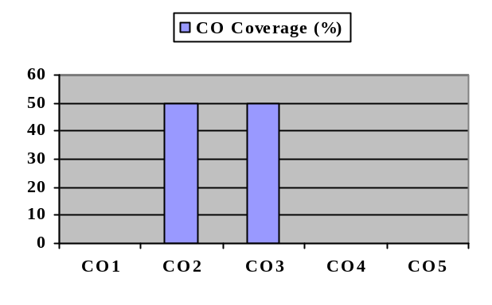 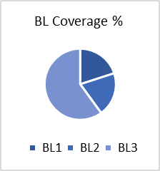

Approved by the Audit Professor/Course Coordinator

